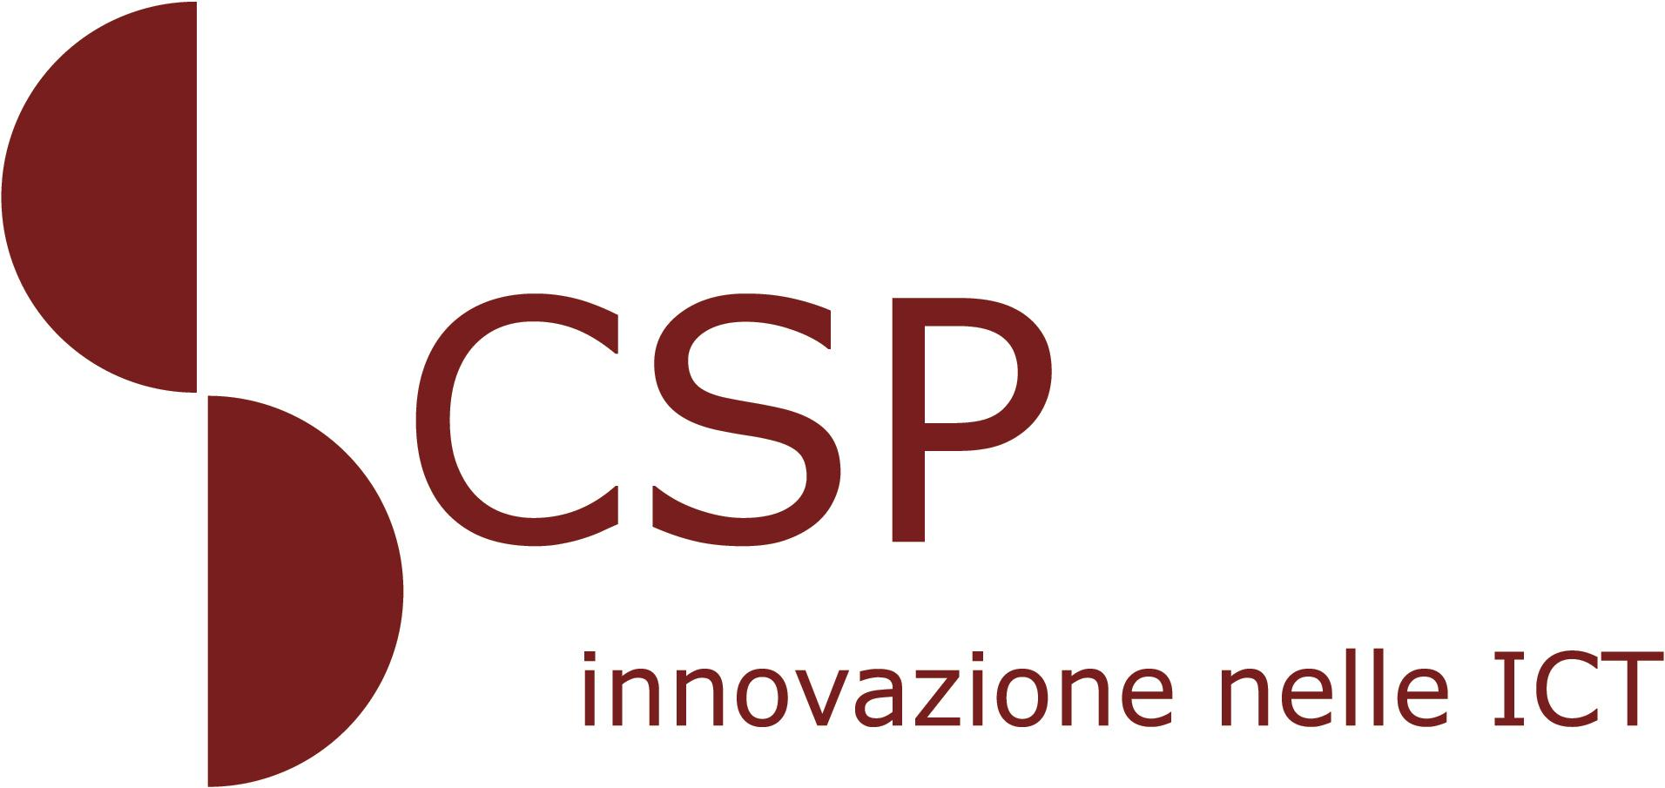




PIEDMONT, ITALY, THE WORLD’S FIRST REGION TO BROADCAST BACKWARD COMPATIBLE 3D TV

New 3D Digital Terrestrial Television, Which Everyone Can Enjoy, Demonstrated During a News Conference in Turin

Turin, 01 December 2010 - Yesterday, in Turin, at the headquarters of the Piedmont Region, a news conference was held announcing the implementation, from Piedmont, of the first 3D HDTV broadcasts, free-to-air, with a system for backwards compatibility with 2D TV sets.
An initiative all made in Piedmont, created through a partnership between public and private bodies operating in the area, including Sisvel, Quartarete TV and CSP Innovazione nelle ICT, putting the region, in northwestern Italy, at the forefront in Europe for developing leading technology for future years.
With the starting of digital terrestrial TV 3D broadcasts within the Quartarete TV service bouquet, Piedmont also becomes the first region in Italy to broadcast free-to-air, backward compatible 3D TV content, allowing those with HD TV sets to watch 2D HDTV, even when the transmissions use 3D techniques.
This is possible due to an innovative technique for formatting stereoscopic images, known as 3D Tile Format, which makes it possible to integrate two 720p frames within a single 1080p frame. The reconstructed right and left images maintain their original resolution, preventing an unbalancing of the vertical or horizontal resolution.
The 3D Tile Format improves the quality of the transmission of 3D HD content, compared to current solutions (Side-by-Side or Top-and-Bottom) and, due to its backwards compatibility, allows broadcasters to transmit to both 2D and 3D users without having to double the amount of bandwidth required for transmissions.
Once again - as it was for the first TV transmissions - Piedmont is leading a process of significant industrial, technological and economic value, providing a roadmap to be followed over the coming months by other regions in both Italy and Europe.
Yesterday’s news conference involved Massimo Giordano, Councillor for Economic Development, Research and Innovation; Roberto Dini, Founder of Sisvel; Giovanni Ferrero, Chairman of CSP - Innovazione nelle ICT; and Davide Boscaini, Director of Quartarete.
The President of the Piedmont Region, Roberto Cota, commented: “I never get tired of repeating that Piedmont has to protect and support its industrial future. The result which we see before us today, an absolute innovation in the national and international broadcasting scene, is the fruit of the virtuous cooperation between public and private research. It is a perfect example of how technological innovation and an entrepreneurial vocation can act in favour of the local area as a development accelerator. It is also an industrial initiative which puts Piedmont at the forefront in Europe, and leading technology, for future years.”
Massimo Giordano emphasised how: “Applied research activity, if well-directed, helps with the development of new products and new business. 3D ‘made in Piedmont,’ therefore, becomes a model which, by opening a road which Italy and Europe must travel in the coming months, is developed thanks to the work of researchers of CSP, a business part owned by the Piedmont Region. Let’s not forget that because it is a point of pride for us and it is a model which is totally in line with the strategies put in place by our Board with the measures specified in the employment and competitiveness plans. Piedmont has everything it needs for taking on the future, which necessarily also involves technological innovation and research.”
Roberto Dini emphasised the innovative features of 3D Tile Format system: “With our partners, we have done some great research and development work and made it tangible. 3D Tile Format technology introduces considerable benefits for the entire market, from operators to TV producers to consumers, and we hope that many other national and international players adopt it soon, so we are already working with them. The standardisation bodies themselves are assessing the adoption of our system. It is worth emphasising that this is a project which offers a positive image of the country, as the entire value chain of the technology, including the set-top-boxes for receiving the signal, has been developed and produced in Italy.”
Davide Boscaini focused on the strategic role of the private broadcaster: “The involvement of Quartarete as broadcaster is a further demonstration of the importance of the role of the private local broadcaster within the Italian TV system. Never before like now is it necessary that local operators can look beyond the horizon and define new strategies for innovation excellence.”
Giovanni Ferrero emphasised: “Yesterday, we presented the results of a good model of partnership between research and business and between public and private. This shows that bringing together research and business is not just possible and virtuous but is a necessary path for keeping the industrial profile of our area high, and that CSP is ever-increasingly involved in this area. It is even more significant that these results have been obtained thanks to the work and the creative talent of young researchers at CSP and Sisvel with an avant-garde solution at an international level.”

Sisvel Profile
Founded in 1982 in Italy, Sisvel is today an international leader group in the global promotion of innovation and the subsequent economic exploitation of results through patents. Since 2008, the Sisvel Group has been supported by the services of Sisvel Technology, a company dedicated to research, development and technical consultancy, which provides strategic advice to other companies in assessing the economic and technical potential of patents. In addition, Sisvel Technology actively develops its own new patented technologies. Sisvel Technology is currently working on the development of new technologies in the 3D TV area in order to facilitate operators and producers of content with the creation and distribution of 3D material.

CSP Profile
CSP - Innovazione nelle ICT is a regional research body for IT&C technologies. It operates at a local, national and international level within experimental development and industrial research activities in accordance with European standards on Innovation and R&D. Its partners are: the Piedmont Region, CSI-Piemonte, Turin Polytechnic, the University of Turin, Turin City Council, the Turin “Industrial Union” (UIT), SISVEL S.p.A. and IREN Energia S.p.A.

Quartarete Profile
Quartarete, a regional Piedmont broadcaster with headquarters in Turin, Novara and Vercelli, thanks to a capillary network of high-frequency systems, guarantees 91% penetration of the Piedmont region (source: Auditel), also providing excellent TV coverage in important parts of Varese, Pavia, Lomello and Milan. 3D technology is an opportunity for radical renovation of the TV world and has led to the upgrading of the broadcaster’s system network, creating a structure which can produce scalable video content within the various systems, 3D, Full HD, SD and Internet.

Press contacts:
Regione Piemonte – Luis Cabases e-mail: luis.cabases@regione.piemonte.it tel. + 39-011-4323934
Sisvel – Federica Brotto e-mail: federica.brotto@sisvel.it tel. +39-011-9902301
CSP Innovazione nelle ICT – Maria Costanza Candi email: candi@csp.it tel. +39-011-4815111
Quartarete – Ottavio Zanotti email: ottaviozanotti@quartaretetv.it tel. +39-011-0015106

